**NAME -DEVESH SINGH**

**BIT MESRA (2018 – 2022)**

**PHASE-2 PROJECT**

**PROJECT TITLE – FLYAWAY**

**(**[**https://github.com/Devesh0110/Project_Phase2_Devesh**](https://github.com/Devesh0110/Project_Phase2_Devesh)**)**

(Home Page)

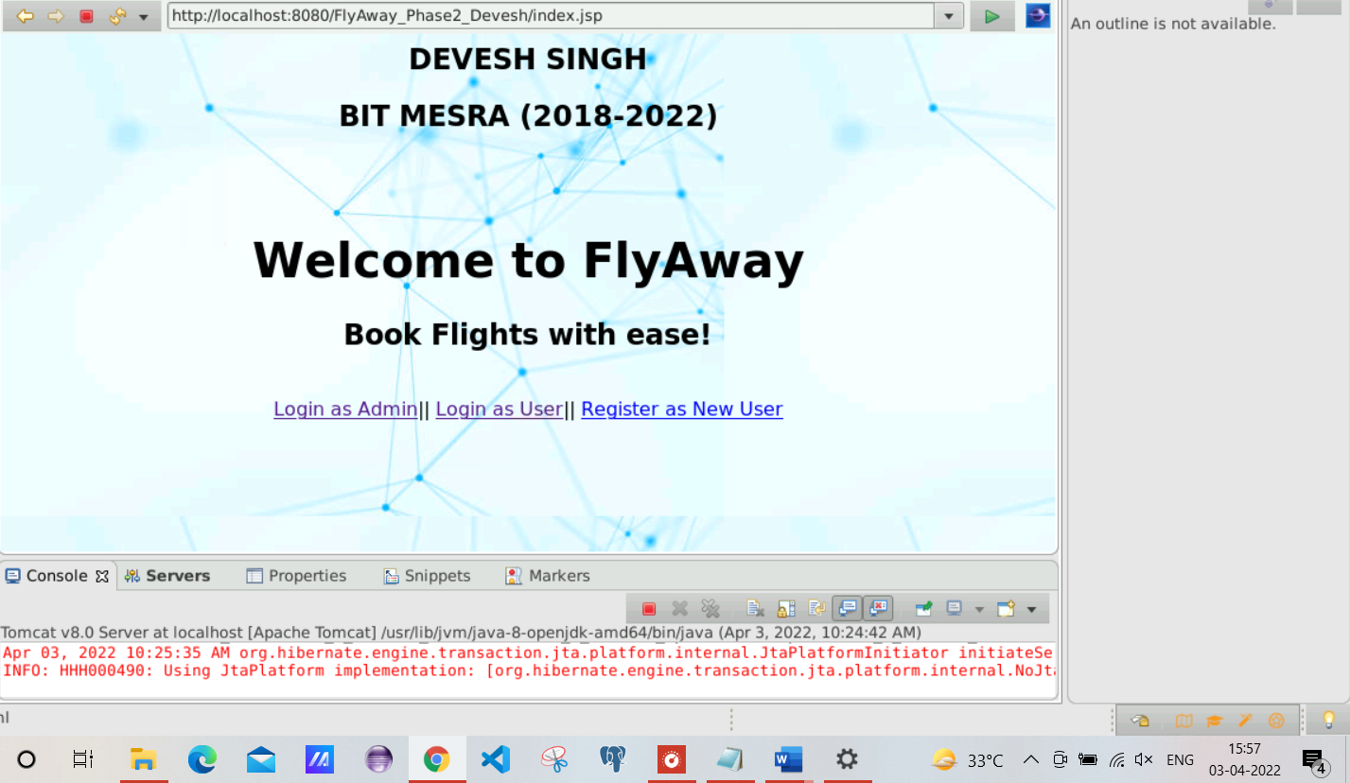

(Database view, which shows that I have an admin registered along with its user id and password)

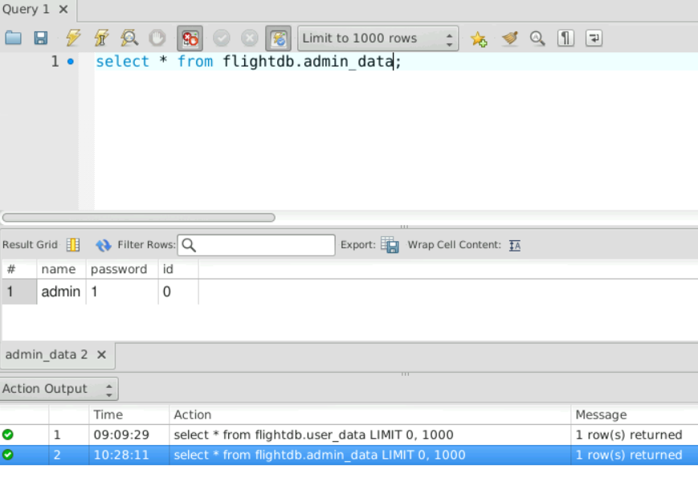

1. ADMIN PERSPECTIVE

(logging in as admin)

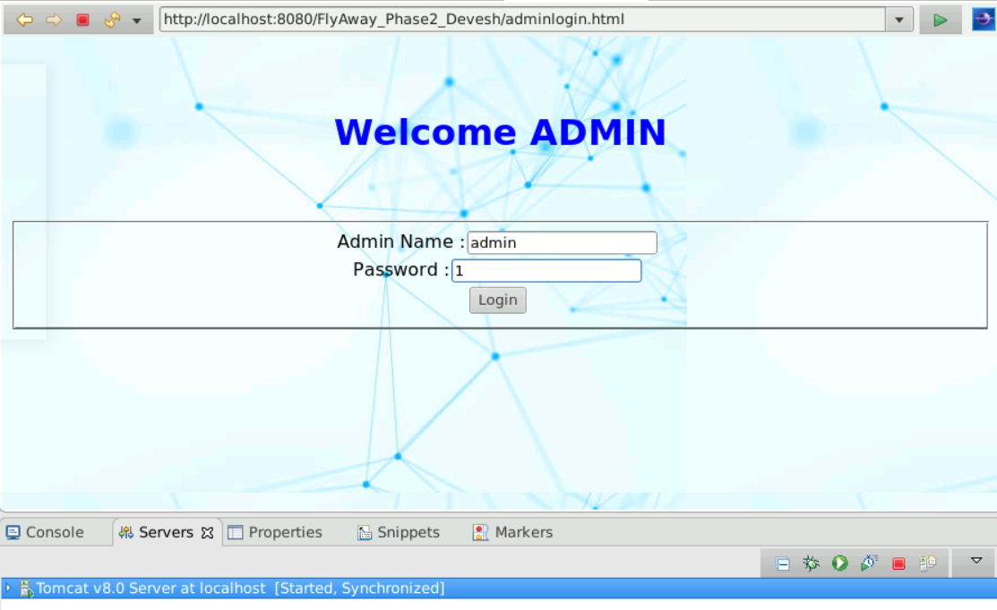

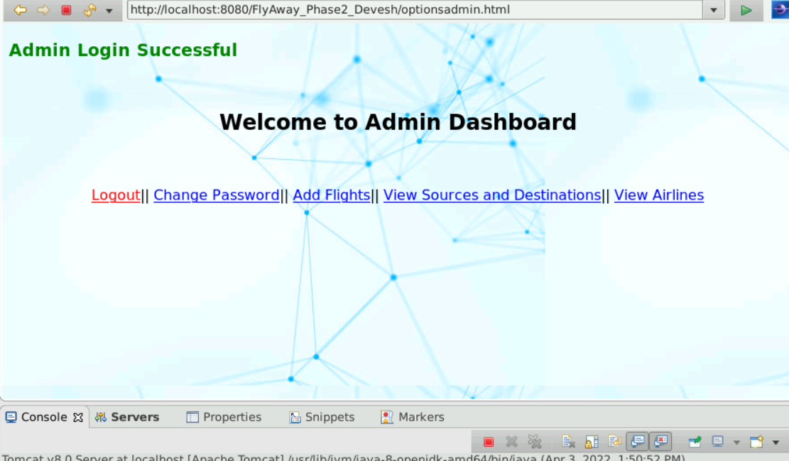

1. Changing password

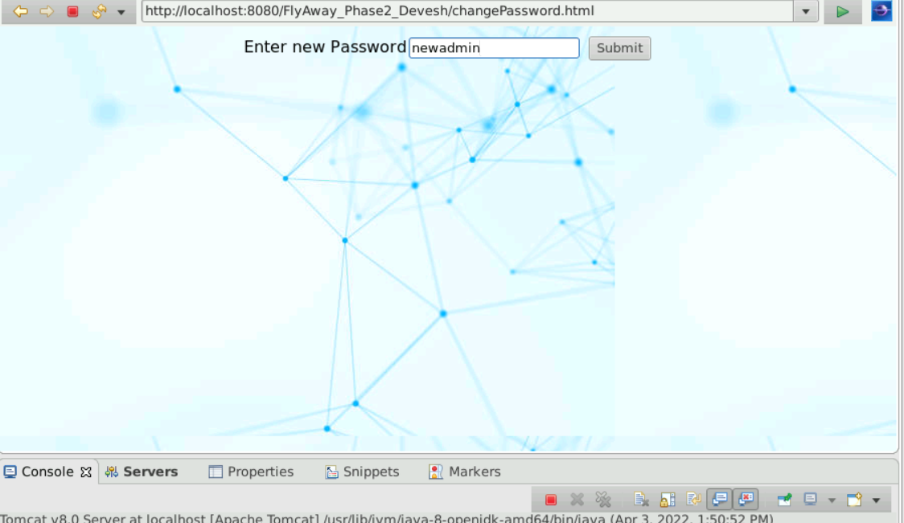

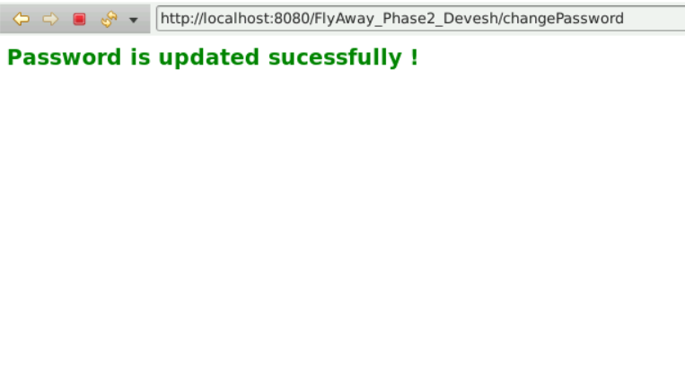

(database view that shows the updated password)

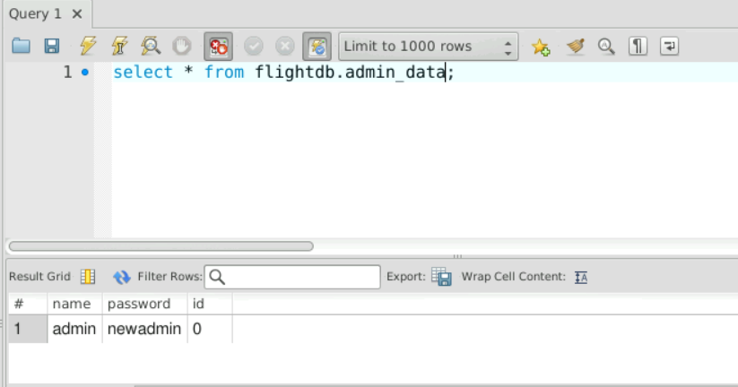

(Logging out and logging in with the changed password)



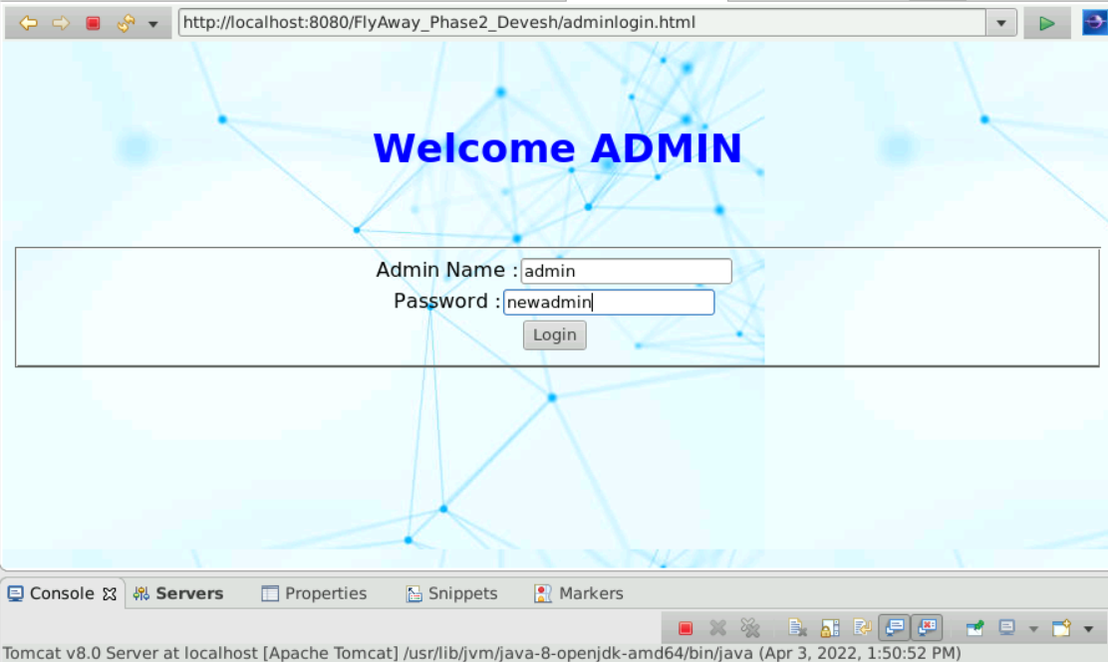

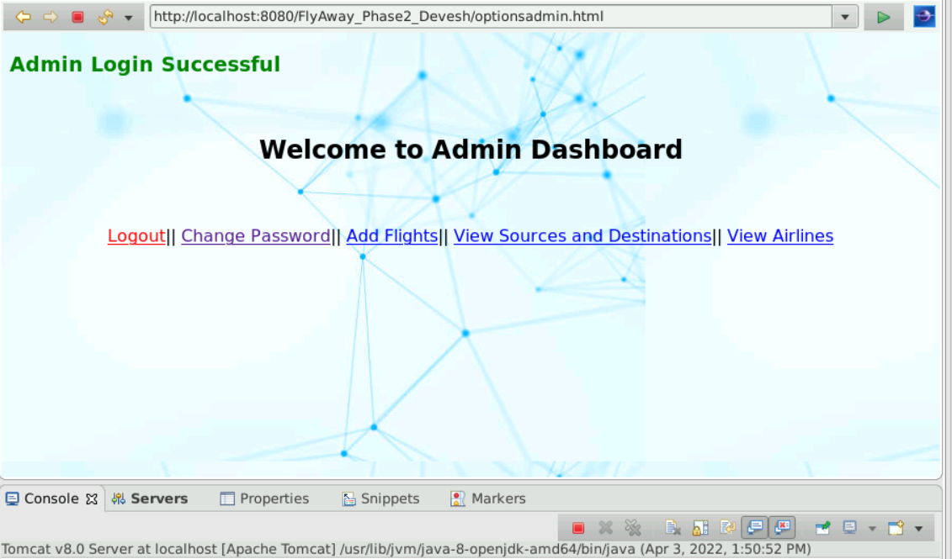

1. Add flight

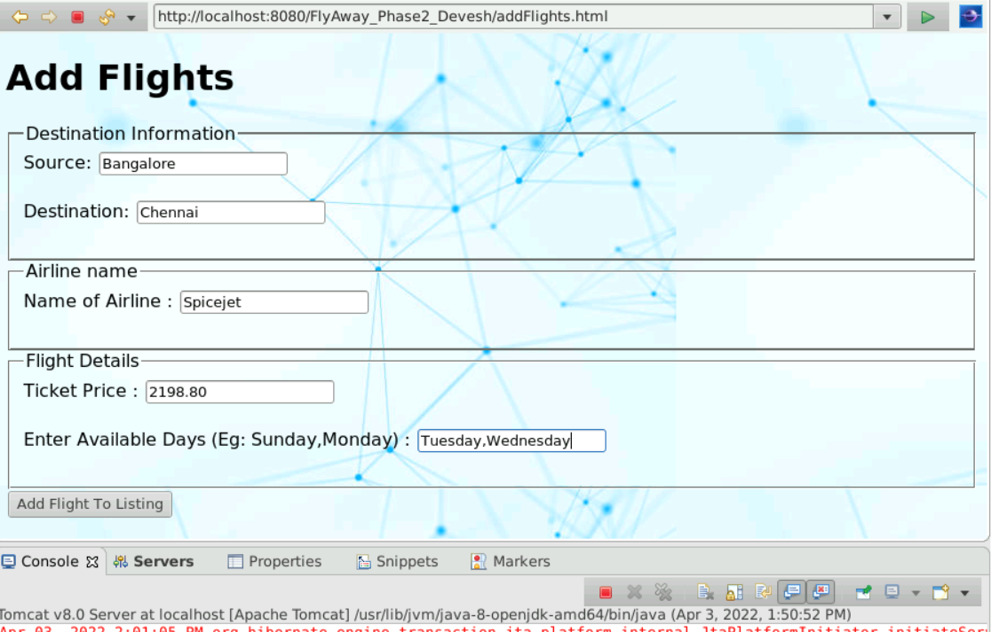

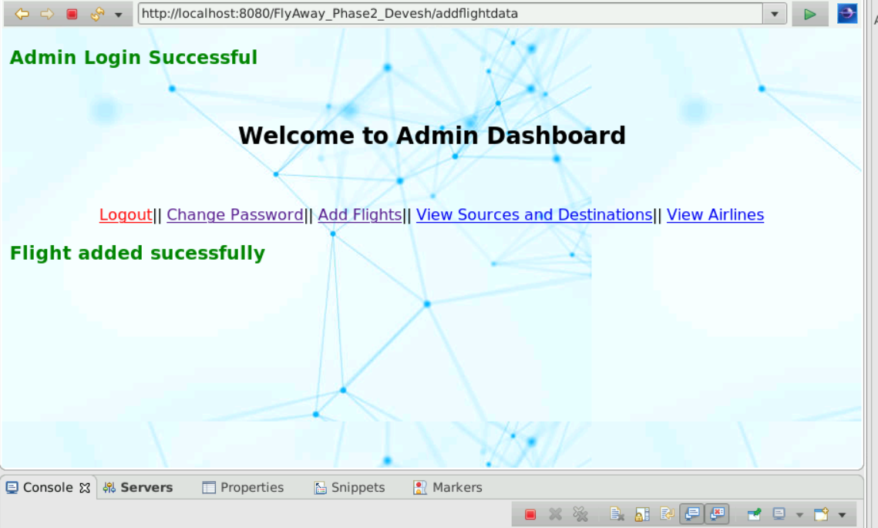

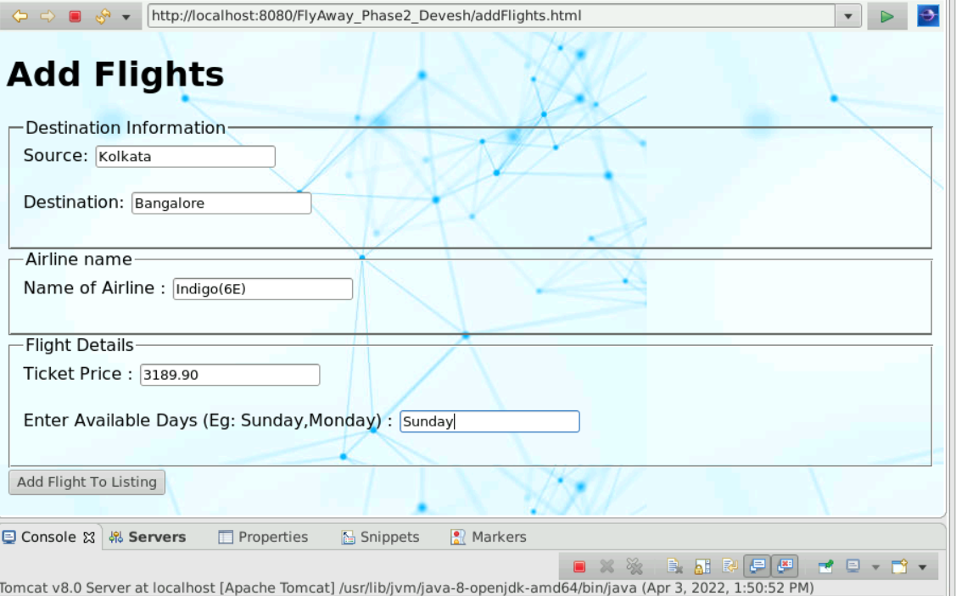

DATABASE VIEW

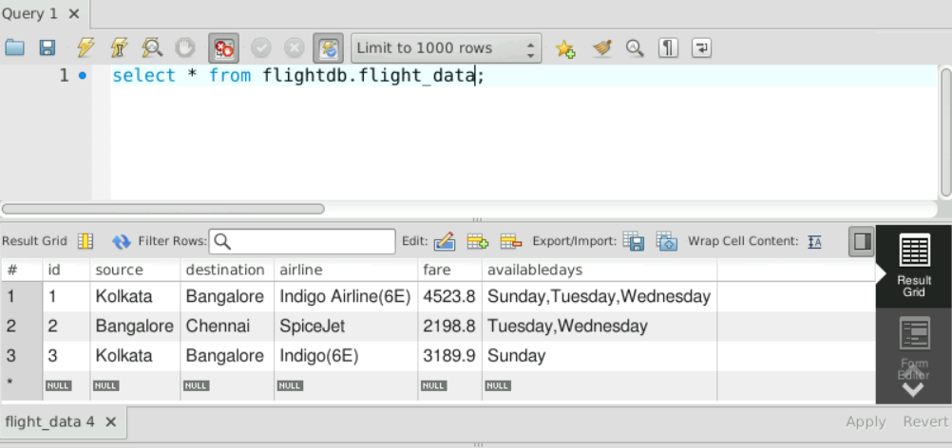

(Previously, I had also added another Kolkata to bangalore flight of Indigo)

1. View sources and destinations

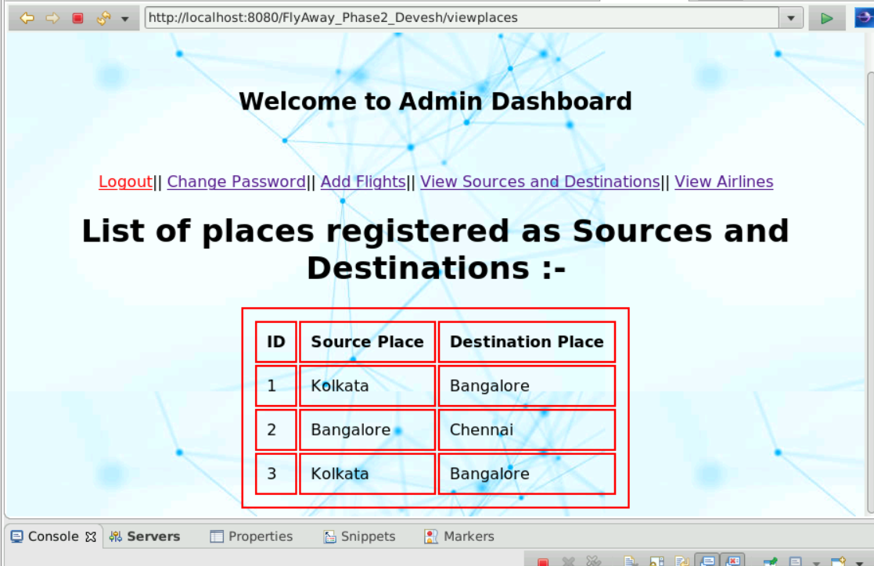

1. View Airlines

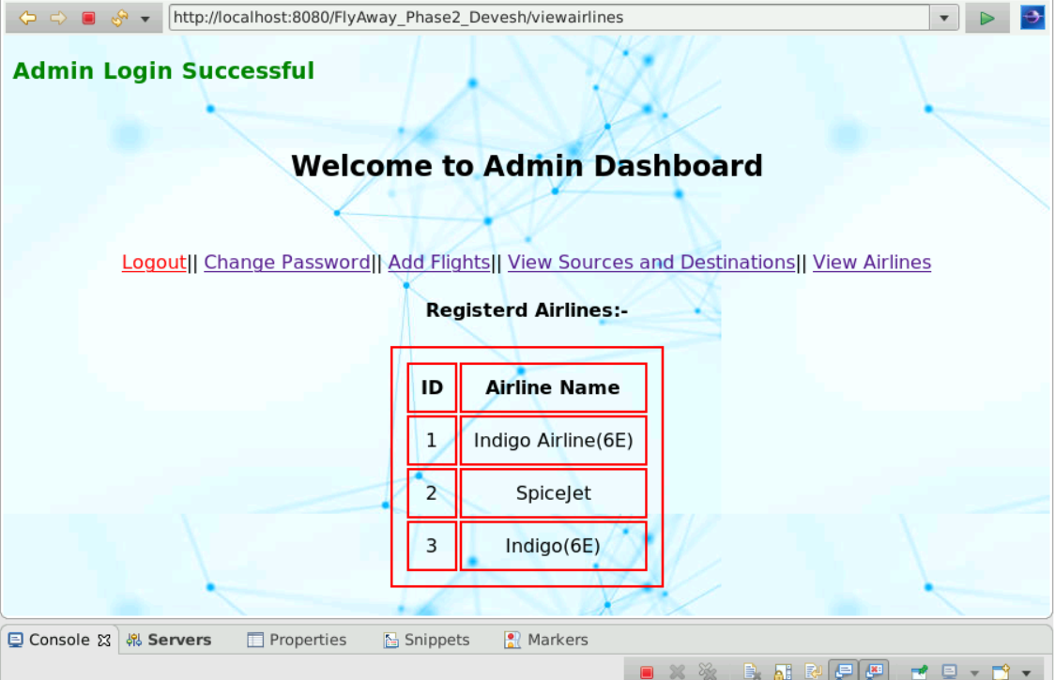

1. **USER PERSPECTIVE**
2. Register as a new User

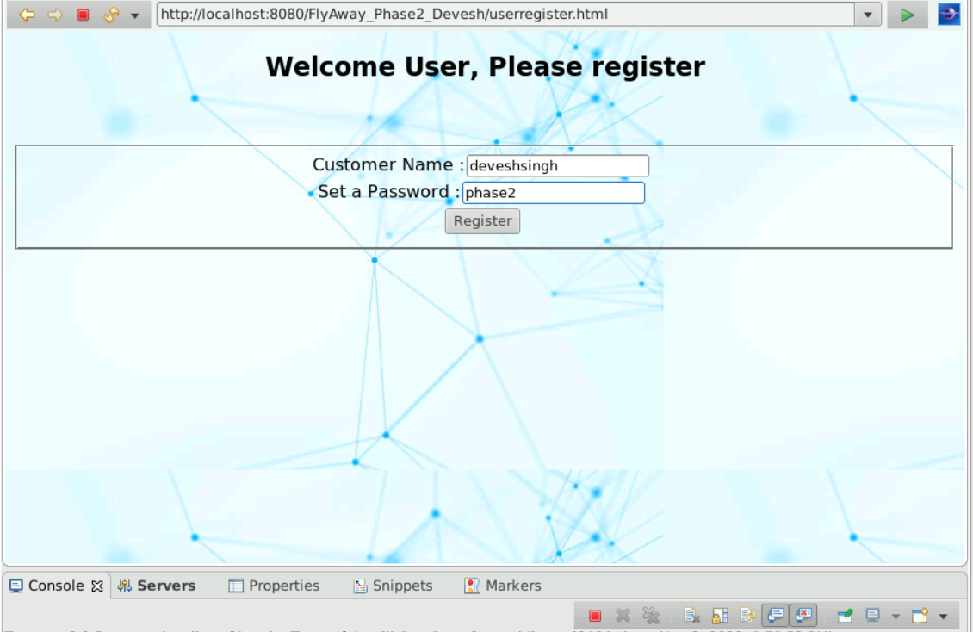

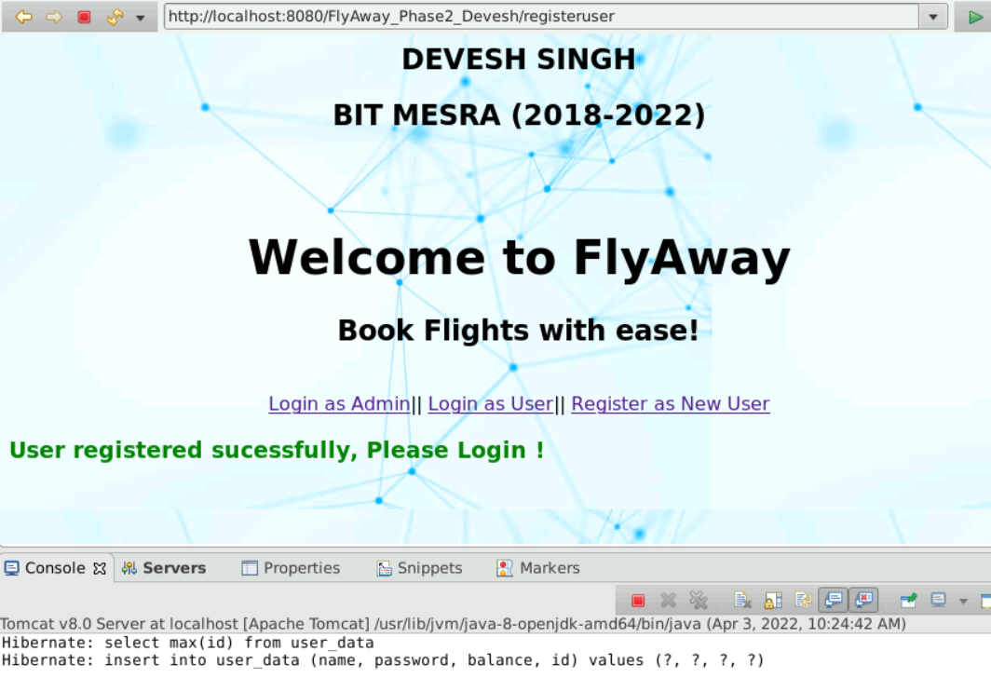

(DATABASE VIEW) – INITIALLY USER HAS A WALLET BALANCE OF 5000

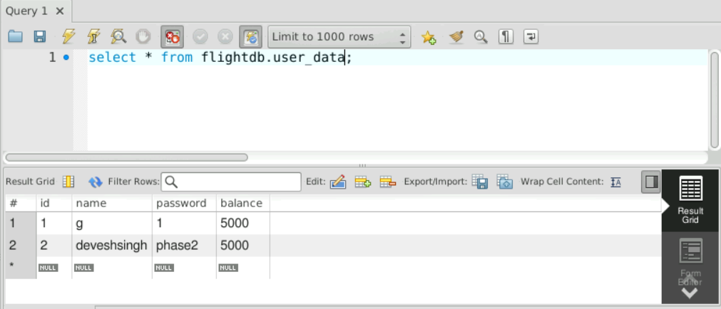

(here, g was a user that I had created for testing the fuctionality)

1. Login as User

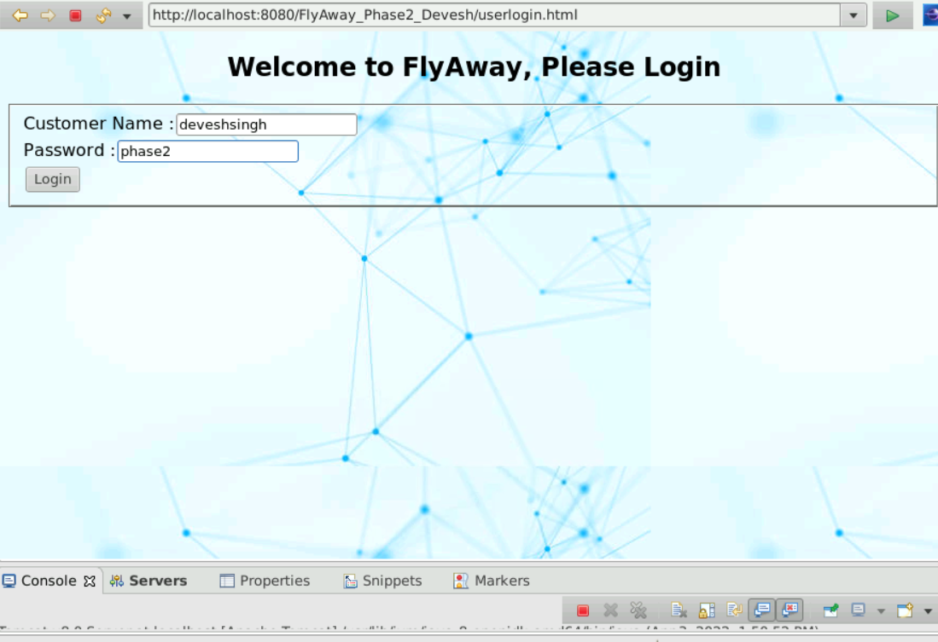



1. Book Flight

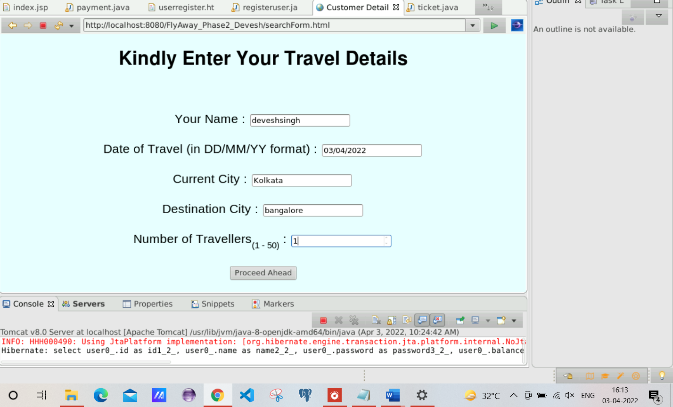

(Booking a flight from Kolkata to bangalore for the 3rd April, which is a Sunday)

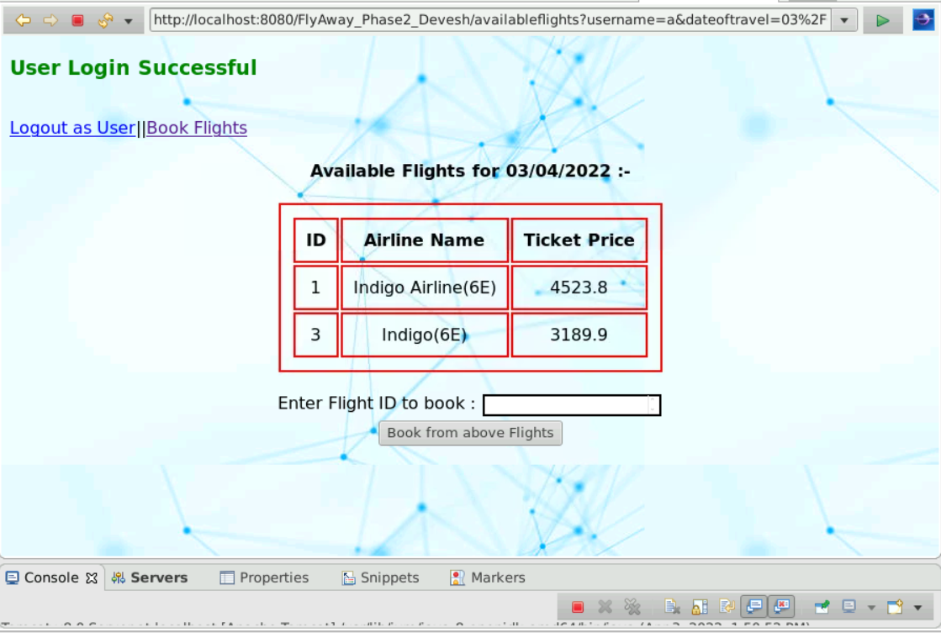

Booking flight with id 3

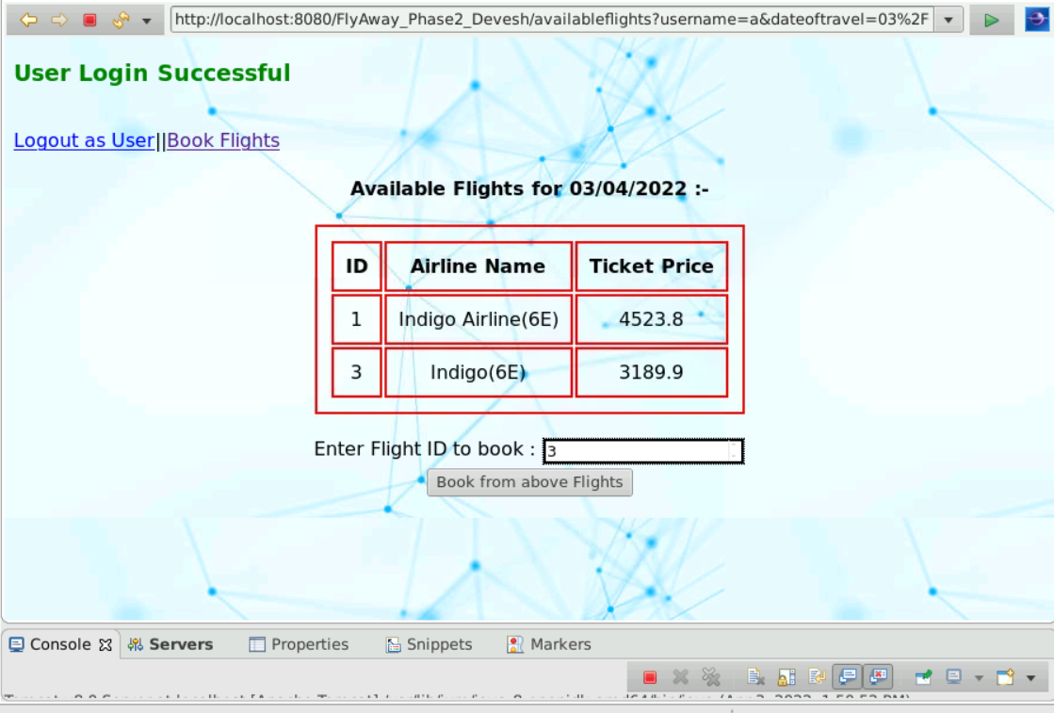

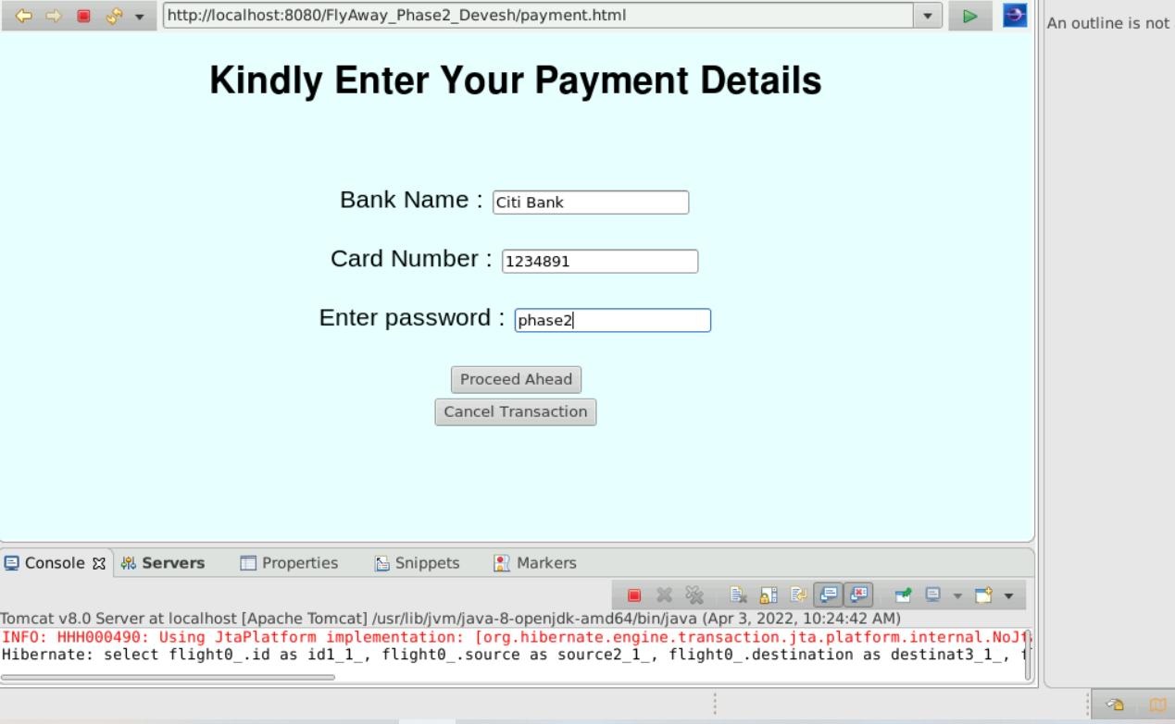

(Proceeding with the transaction)

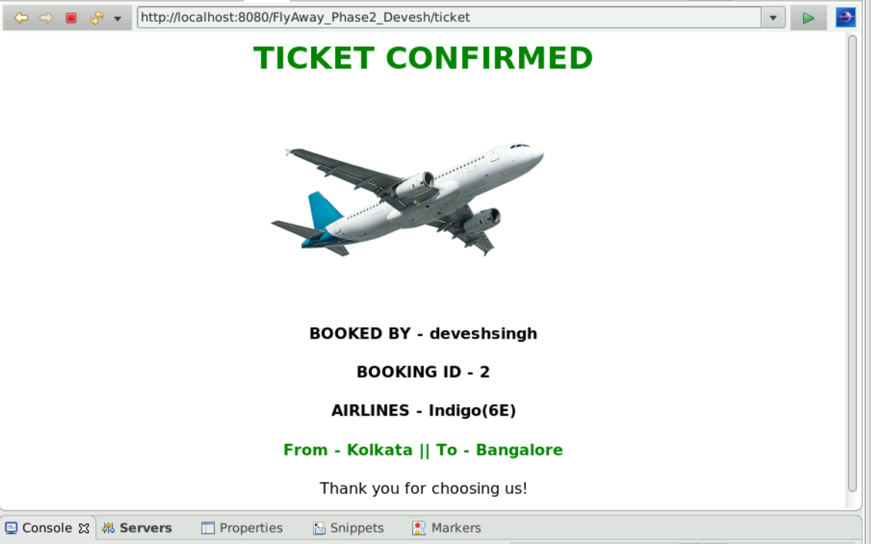

**(TICKET BOOKED)**

(AFTER BOOKING, USER BALANCE IS ALSO REDUCED BY THE AMOUNT OF THE TICKET)

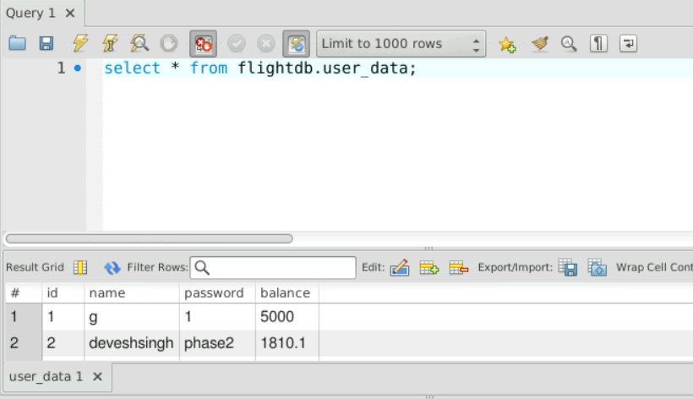

**CORNER CASES THAT I HAVE HANDLED**

1. User tries to search for a city which does not have any flights running / user tries to search for flights on a date in which flights are unavailable

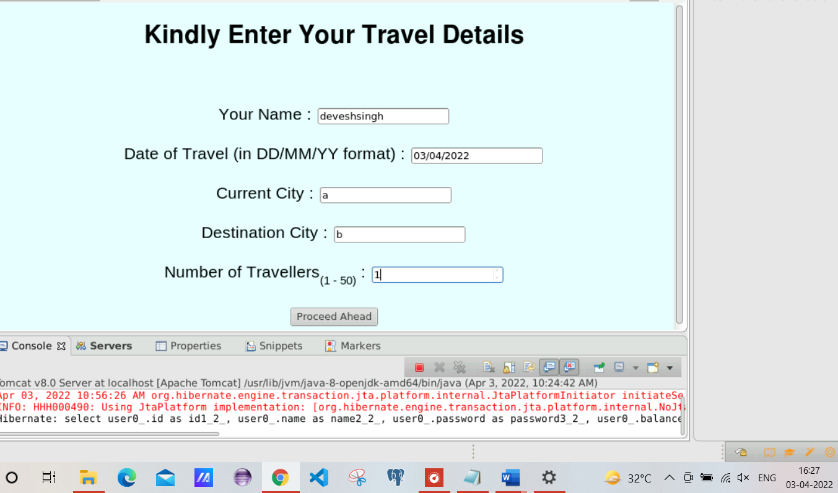

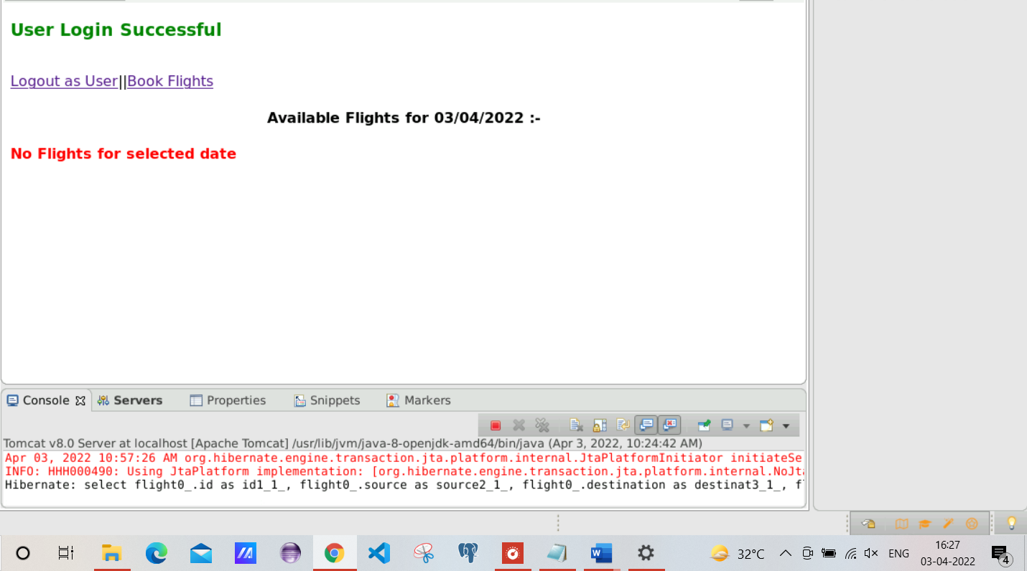

1. If existing User tries to register again

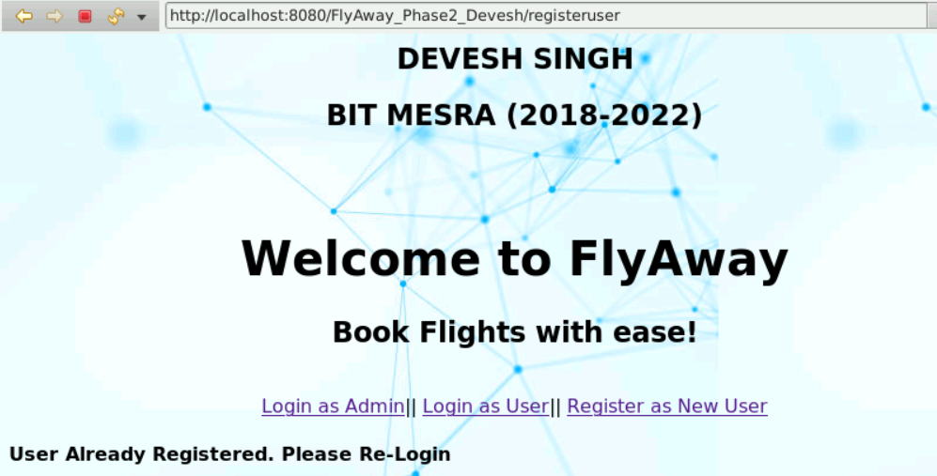

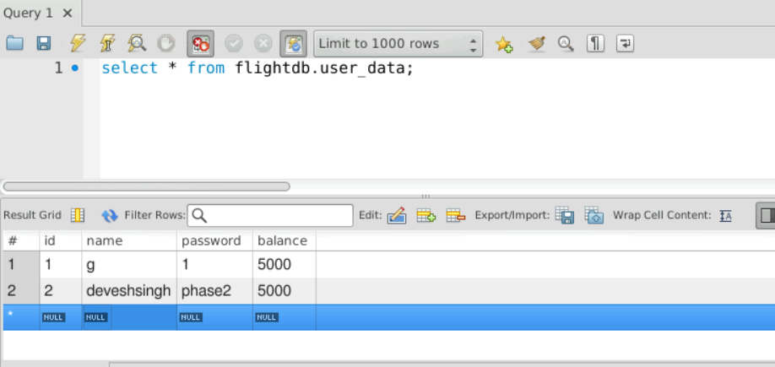

1. If user tries to login with wrong id

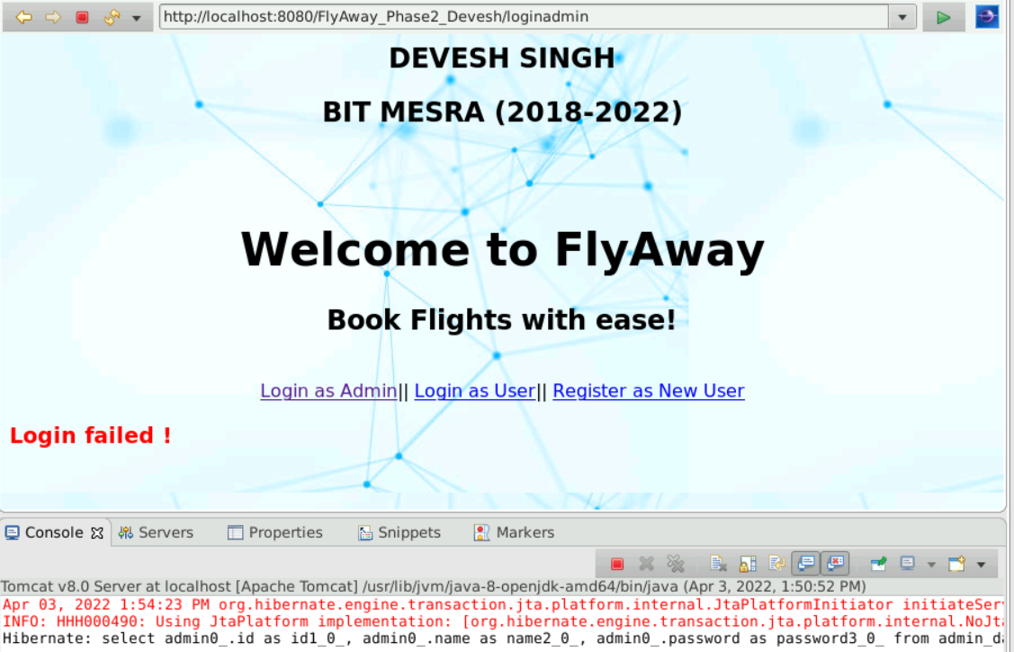

1. If user tries to book tickets that cost more than the amount of balance he has. Eg: if user (deveshsingh) tries to book Kolkata to bangalore flight for 2 people then amount=(3189.9 X 2) which is greater than 5000 (The account balance for the user)

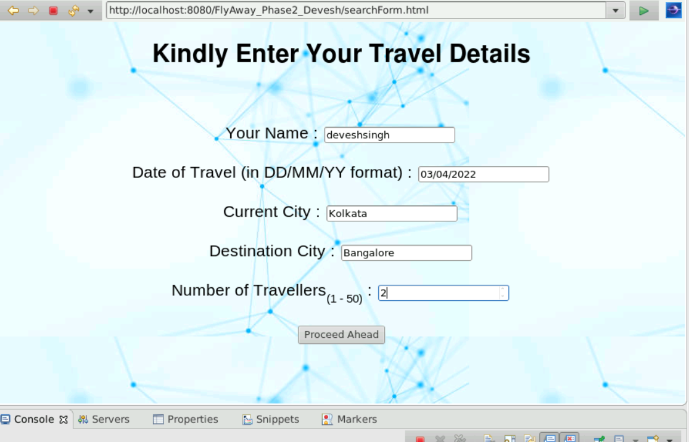

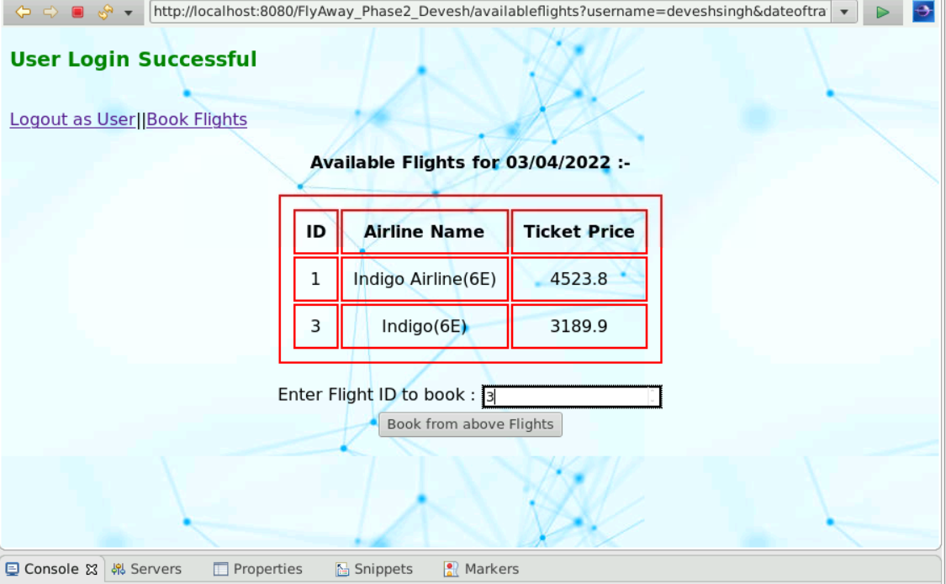

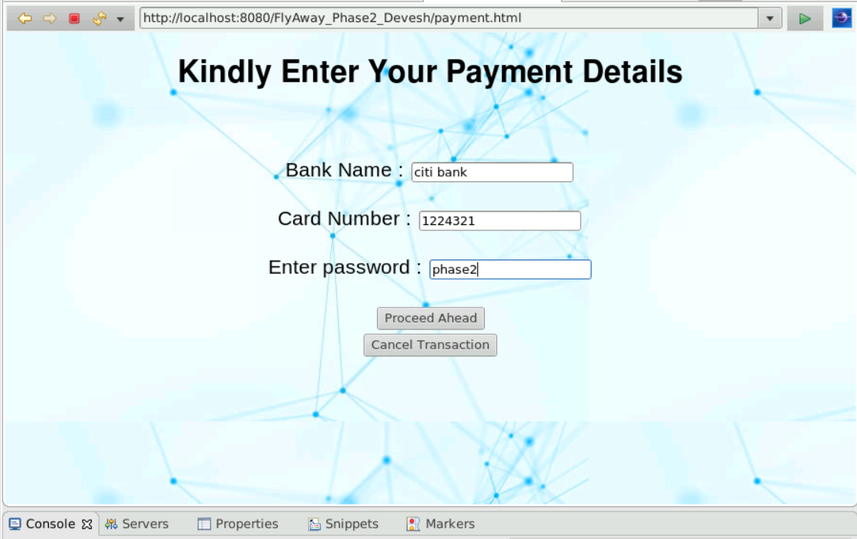

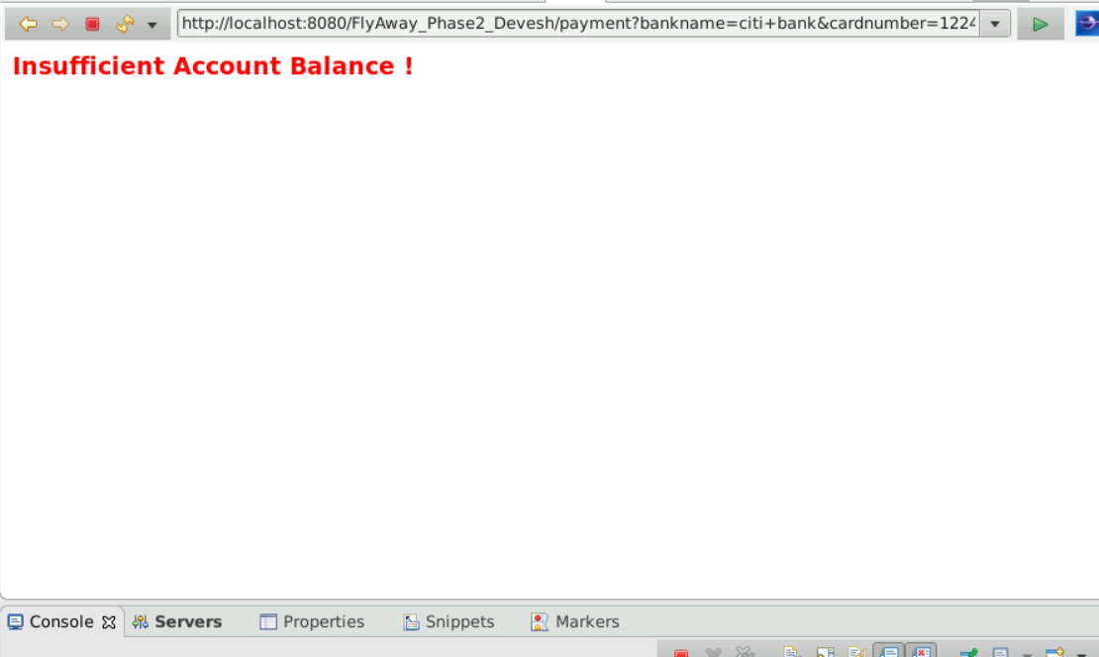

(Transaction terminated due to low balance)